Prepared Exclusively for:

Submitted by:
Howard Jones

Dealer

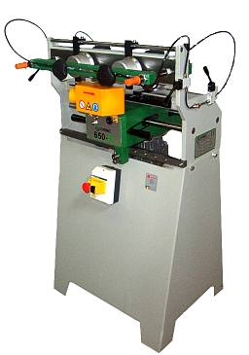


Omec 650M Milling Machine

Date

Attn:

MACOSER, INC. is pleased to offer the following:

OMEC MODEL "650M" MILLING MACHINE FOR DOVETAIL JOINTS

This hand operated milling machine is used to indent dovetails for drawers and various furniture elements. The machine is equipped with a mill spindle which allows cutting of indents of variable height. The machine can cut single male or female work pieces, or both simultaneously. The locking and release of the pieces take place manually by means of pneumatic valves.

Dovetail Joints
The dovetail, an exclusive feature of our routing machines, provides a lasting joint in the various component parts of boxes, drawers or other items of furniture.
With this type of joinery, finer quality in the finished item is guaranteed and the final product automatically increases in value, thereby marginally influencing its cost.

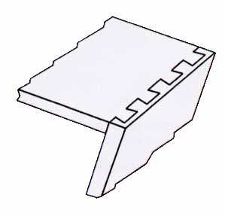
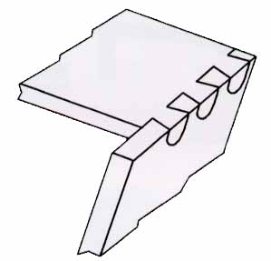
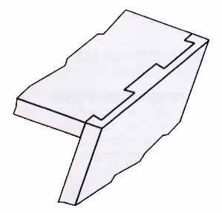
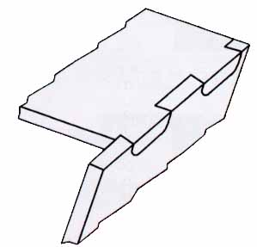
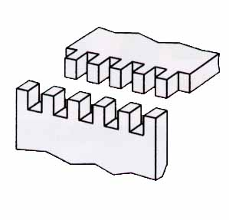
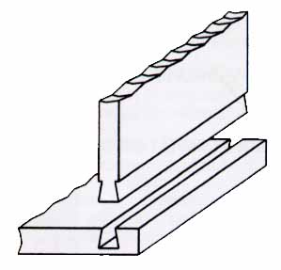
TECHNICAL DATA:

On board machine installed power | 1 HP
Number of spindles | 1
Spindle revolutions | 16,500 rpm
Center to center of dovetail | 0.98", 1.57”, 1.97”, 3.15”  25mm-40mm-50mm-80mm
Machine net weight | 286 lbs/130 kg
Machine packaged weight | 330 lbs/150 kg
Overall dimensions | 31.5" x 28.35" x 51.97"  80cm x 72cm x 132cm
Packing dimensions | 35.43" x 29.53" x 55.12"  90cm x 75cm x 140cm

DIMENSIONAL LIMITS OF WORKPIECES:
Dimensions | Length | Width | Indent Height | Front Thickness | Side Thickness
Minimum | 7.87”  200mm | 2.36”  60mm | .31”  8mm | .28”  7mm | .28”  7mm
Maximum | 59.06”  1500mm | 16.54”  420mm | .71”  18mm | 2.36”  60mm | 1.18”  30mm

STANDARD EQUIPMENT:

- Eccentric HSS mill cutter assembled on the machine
- Plates kit for indent break
- Tool kit for adjustments and maintenance
- User's and instruction manual

STANDARD LIST PRICE OF OMEC 650, F.O.B. Charlotte, NC $ 6,588.00

AVAILABLE OPTIONS:
Prices of “Available Options” are with purchase of machine only.
Equipment for the machining of small pieces | $ 3,843.00
Anti-splintering Wood | $ 15.00
Special pitch adapter kit | $ 1,380.00
Eccentric HSS Mill spare cutter | $ 89.00
Eccentric HM Mill spare cutter | $ 99.00
Cylindrical HM Mill spare cutter | $ 114.00
Template for French Dovetails | $ 246.00
Cylindrical HM Mill Cutter for Special Pitches | $ 453.00
Template For Box Taper Dovetails | $ 966.00

MACHINE AND OPTIONS PROPOSED FOR ??? :

(1) Omec 650M Dovetailer $6,588.00
(4) Anti-Splintering Wood @ $15.00 each $ 60.00
(1) HM Spare Mill Cutter $ 99.00

TOTAL PRICE FOR MACHINE AND OPTIONS PROPOSED,
F.O.B. Charlotte, NC $ 6,747.00

