

Castle TSM-35 Pocket Boring Machine
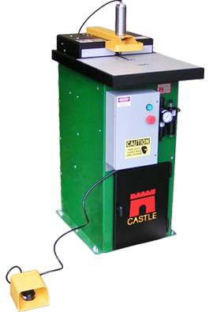
Quotation Presented To:
(Company Name )– (Customer Name)
Presented By: (Salesmen Name) – RT Machine Company
Date:

TSM-35
Heavy Duty Pocket Cutter

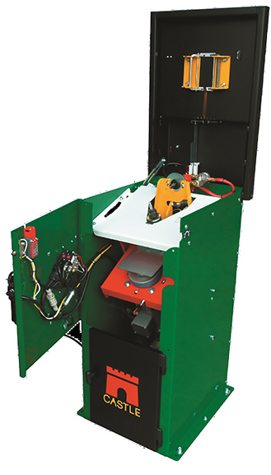
The TSM-35 cuts the same patented 6 degree Castle Pocket as the TSM-21. This machine is designed for continuous production in furniture plants, mobile home factories, multi-shift cabinet production and so much more. A heavy duty, three-phase induction motor drives the pocket cutting spindle and is available in 208v, 230v or 460v. A specially designed, high torque, heavy duty air motor drives the pilot bit.
The TSM-35 features heavy duty construction throughout with easy, top-down access for quick router and drill bit changes and adjustable Indexing Stops built into the top for quick part transitions during high production shifts. The TSM-35 can produce more than a quarter million pockets per month for years on end with minimal maintenance.
Build with Quality, Build with Castle!

Tech Specs:
- Router = 1-1/2HP Baldor Router Motor
- Router Bit = Premium 3/8″ Solid Carbide, Rough Mill
- Drill = Sioux SDG10S25FCT Air Motor
- Drill Bit = 9/64” Brad and Spur Premium TiN Coated Bit
- Power Req = Three-phase 208v, 230v, 460v
- Air Req = 85 psi – External Regulator, Filter and Lubricator included
- Basic footprint: 21″ depth x 19″ width
- Working height: 36.5″
- Worktop usable area: 16″ depth x 18.5 width
- Machine height: 38
- Shipping weight: Approx 300 lbs
- Shipping dimensions: 28″ x 24″ x 48″

Machine Price:
FOB: Hughesville, PA

Quotation Valid for a period of 30 days and is subject to prior sale.

Salesman:
(Name)
RT Machine Company
Office: (xxx)-xxx-xxxx
Mobile: (xxx)-xxx-xxxx
Email: (salesman email)

If you have further questions or would like to see more images feel free to contact us at the office (570)-584-2002 or visit our website www.rtmachine.com

Thank you for the interest and hopefully we can have the opportunity to earn your business.



